**Create Key Performance Indicators**

In this demo, you create Key Performance Indicators (KPIs). KPIs are used to gauge performance of a value defined by a Base measure, against a Target value also defined by a measure, or by an absolute value. In reporting client applications, KPIs can provide business professionals a quick and easy way to understand a summary of business success or to identify trends.

## **Creating Key Performance Indicators**

#### To create an InternetCurrentQuarterSalesPerformance KPI

1. In the model designer, click the **FactInternetSales** table.
2. In the measure grid, click an empty cell.
3. In the formula bar, above the table, type the following formula:

InternetCurrentQuarterSalesPerformance :=DIVIDE([InternetCurrentQuarterSales]/[InternetPreviousQuarterSalesProportionToQTD],BLANK())

This measure serves as the Base measure for the KPI.

1. In the measure grid, right-click **InternetCurrentQuarterSalesPerformance** > **Create KPI**.

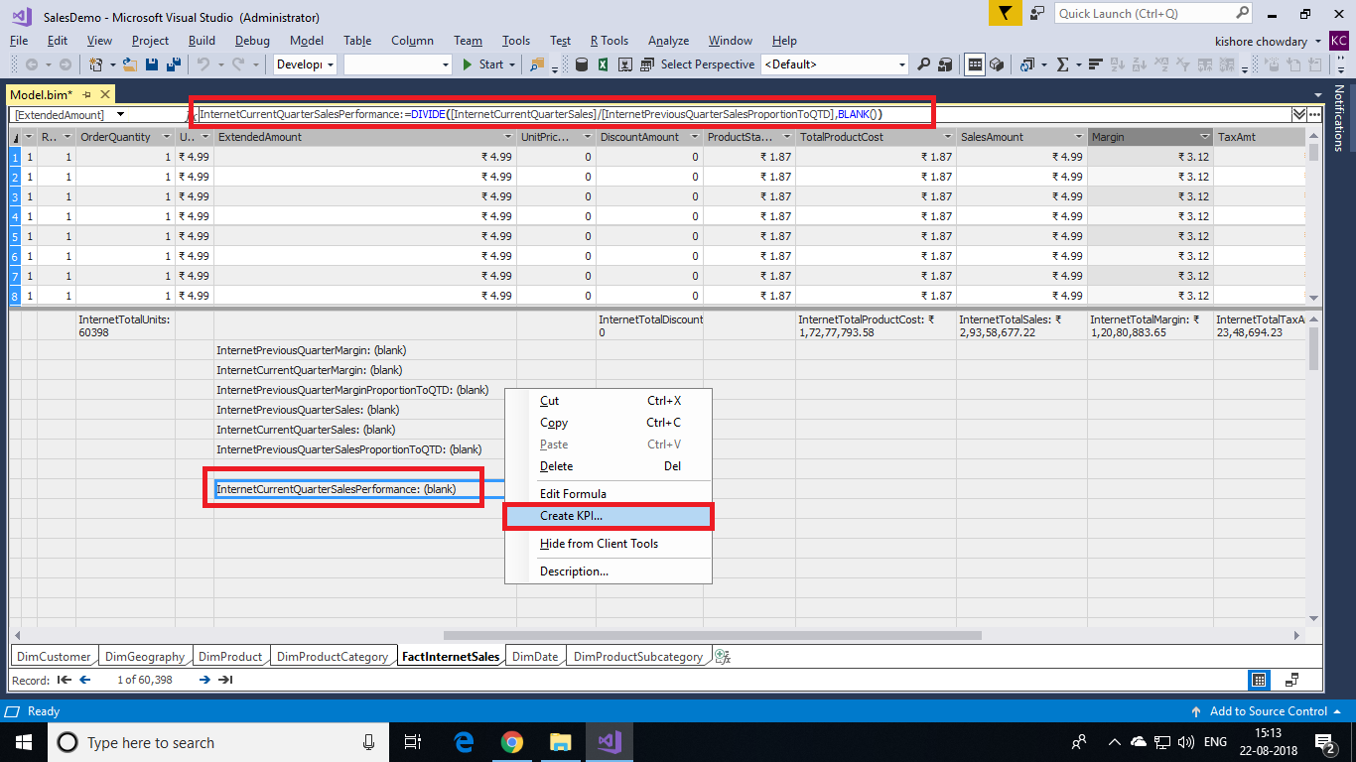

1. In the Key Performance Indicator (KPI) dialog box, in **Target** select **Absolute Value**, and then type **1.1**.
2. In the left (low) slider field, type **1**, and then in the right (high) slider field, type **1.07**.
3. In **Select Icon Style**, select the diamond (red), triangle (yellow), circle (green) icon type.

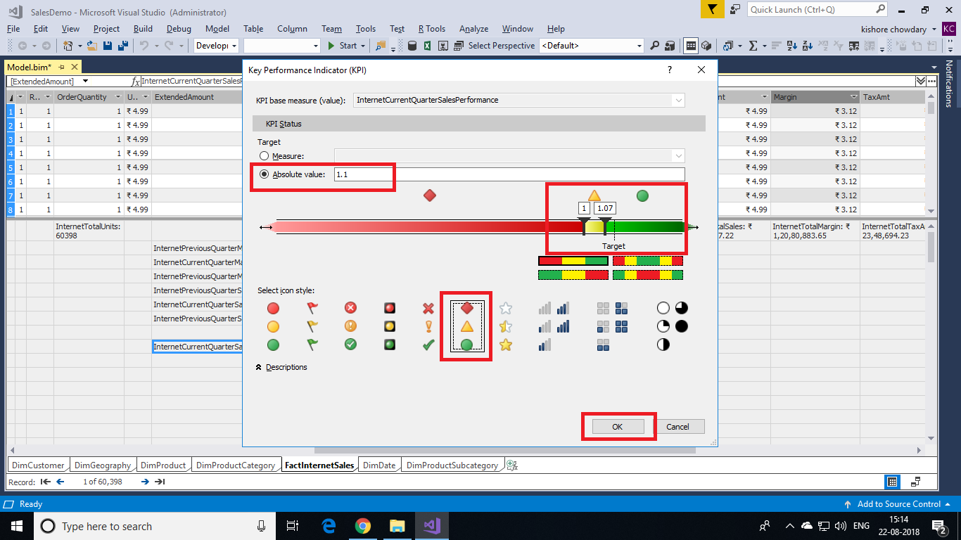

1. Click **OK** to complete the KPI.

In the measure grid, notice the icon next to the **InternetCurrentQuarterSalesPerformance**measure. This icon indicates that this measure serves as a Base value for a KPI.

#### **Creating an InternetCurrentQuarterMarginPerformance KPI**

1. In the measure grid for the **FactInternetSales** table, click an empty cell.
2. In the formula bar, above the table, type the following formula:

InternetCurrentQuarterMarginPerformance :=IF([InternetPreviousQuarterMarginProportionToQTD]<>0,([InternetCurrentQuarterMargin]-[InternetPreviousQuarterMarginProportionToQTD])/[InternetPreviousQuarterMarginProportionToQTD],BLANK())

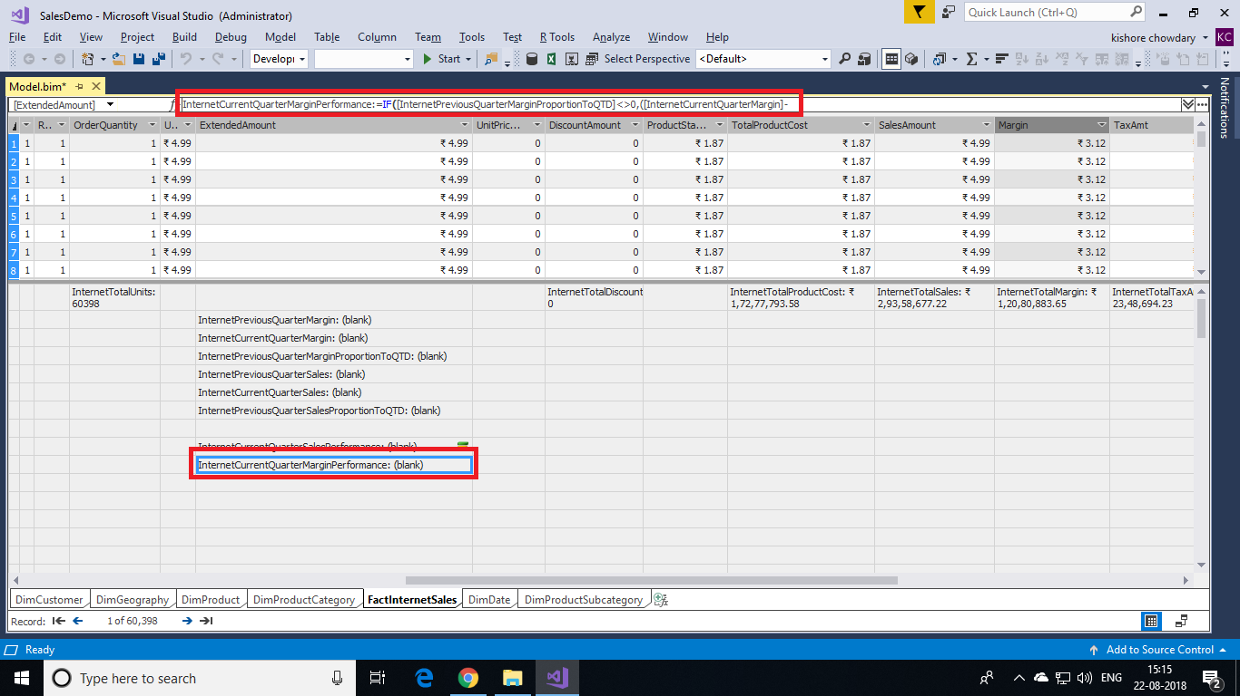

5. Right-click **InternetCurrentQuarterMarginPerformance** > **Create KPI**.

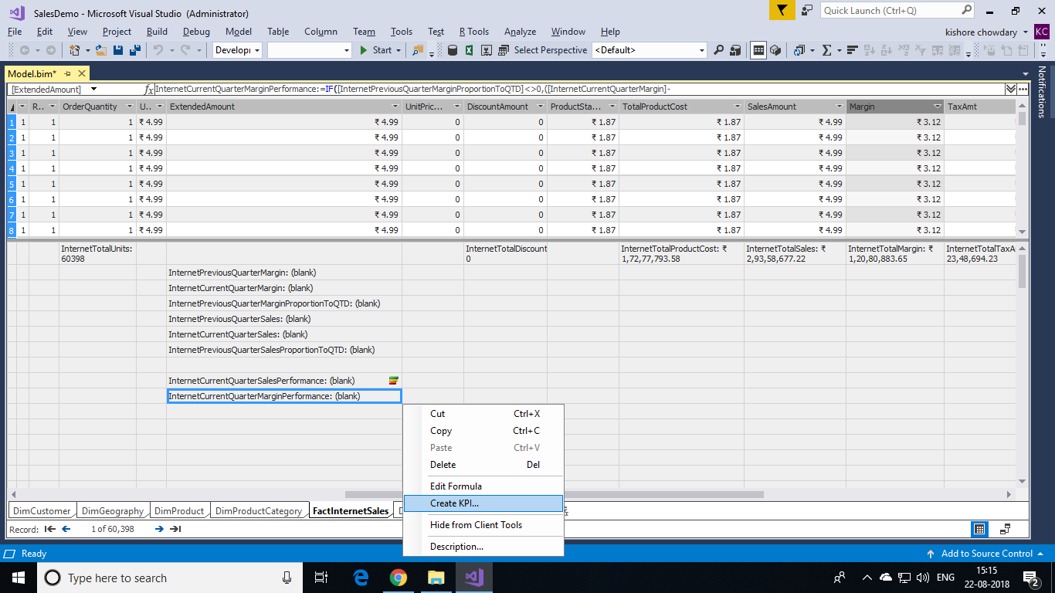

6. In the Key Performance Indicator (KPI) dialog box, in **Target** select **Absolute Value**, and then type **1.25**.

7. In the left (low) slider field, slide until the field displays **0.8**, and then slide the right (high) slider field, until the field displays **1.03**.

8. In **Select Icon Style**, select the diamond (red), triangle (yellow), circle (green) icon type, and then click **OK**.

